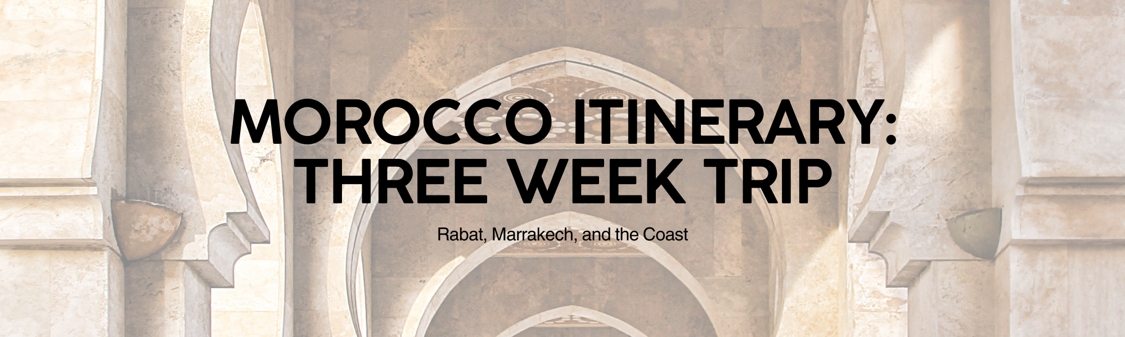
Week 1: Cultural Welcome in Rabat
Where to Stay:  - Riad Kalaa  - Hotel Rabat  - Euphoriad Riad | Recommended Activities:  - Explore the Kasbah of the Udayas. Wander through the blue and white streets.  - Visit the Mausoleum of Mohammed V. A stunning example of Moroccan architecture.  - Discover the Chellah Necropolis. Roman and Islamic ruins in a serene setting.  - Stroll along the Rabat beach. Enjoy the Atlantic coast.  Tips:  - Rabat is more relaxed than other Moroccan cities. It is a great starting point for first-time visitors.  - Learn a few basic Arabic phrases. It will enhance your interactions with locals.  - Dress respectfully. Cover your shoulders and knees when visiting religious sites.
Week 2: Road Trip to Marrakech
Where to Stay:  - Riad Kniza  - La Mamounia  - Riad Yasmine | Recommended Activities:  - Visit Jemaa el-Fna. Experience the vibrant atmosphere of the main square.  - Explore the Bahia Palace. Admire the intricate decorations and gardens.  - Wander through the souks. Haggle for souvenirs and local crafts.  - Visit the Majorelle Garden. A tranquil oasis with striking blue architecture.  Tips:  - Be prepared for the hustle and bustle of Marrakech. It's a sensory overload!  - Hire a local guide. They can help you navigate the medina and avoid scams.  - Stay hydrated. The Moroccan sun can be intense, especially during the day.
Week 3: Slow Down at the Coast (Temuda Bay + Tetouan)
Where to Stay:  - Banyan Tree Tamouda Bay  - Sofitel Tamuda Bay Beach and Spa  - Hotel Blanco Riad (Tetouan) | Recommended Activities:  - Relax on the beaches of Tamuda Bay. Enjoy the calm Mediterranean waters.  - Visit the Medina of Tetouan. A UNESCO World Heritage site with a unique Andalusian influence.  - Hike in the Rif Mountains. Explore the stunning natural beauty of the region.  - Enjoy watersports. Tamuda Bay offers opportunities for jet skiing, windsurfing, and more.  Tips:  - Learn some Spanish. Tetouan has a strong Spanish influence, and many locals speak Spanish.  - Enjoy the fresh seafood. The coastal region is known for its delicious seafood.  - Take a day trip to Chefchaouen. The blue city is only a short drive away.
Summary
This 3-week itinerary provides a balanced experience of Morocco, from the cultural heart of Rabat to the bustling souks of Marrakech and the relaxing coastal vibes of Tamuda Bay and Tetouan. Remember to embrace the local culture, be respectful, and enjoy the incredible hospitality that Morocco has to offer. Safe travels!

